

**CUBIC Scanner booking system**

Please access the calendar at the link below:

<https://www.supersaas.co.uk/schedule/cubic/Scanner_Booking_System>

Please get in touch with Ari (MRI Operations Officer) if you require login credentials.

Once logged on:

You will see the schedule.

You could add your email address (if not given already) to the profile so that you could receive confirmations of your reservations.

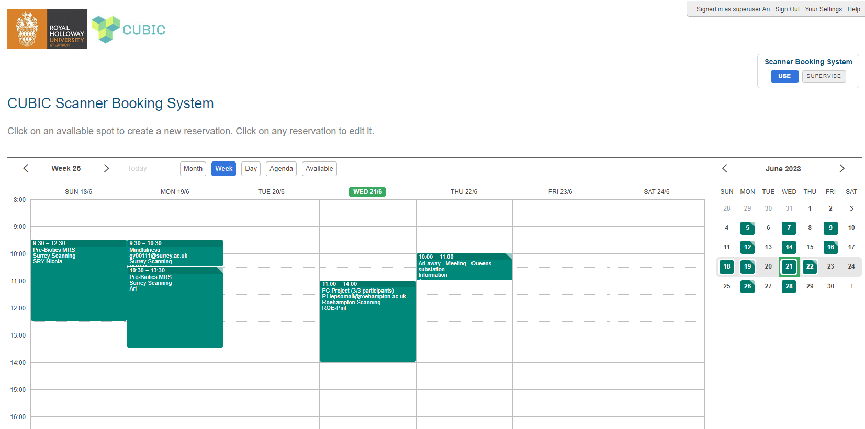

**Making a reservation:**

Click on an available timeslot to get the pop-up.

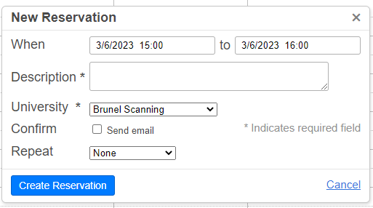

* Default slot is for an hour, but you can edit it.
* In the description box: Please provide the project name (and grant code for RH) and any other details you wish. Please refrain from adding names of the participants.
* Choose your University from the drop down menu.
* You will be able to edit / delete your own bookings until 24 hours prior to the booked slot.
* If you plan to scan more than one person and continuously, please make just one booking with stating the correct start and end times. This reduces the number of bookable future appointments, which is limited based on our subscription to SuperSaaS.

**Editing / deleting your reservation:**

When you click on a booking made by you, it is possible to edit or delete it.

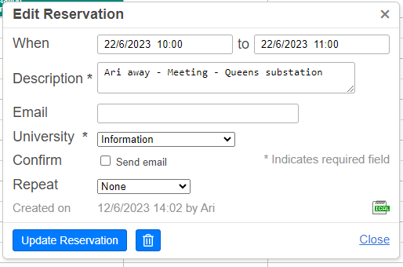

**Changing the password:**

Once logged in, click on “Your Settings” at the top right corner.

When the form “Edit your Information” appears, enter the new password.

